Fachhochschule Kärnten
Carinthia University of Applied Sciences
Systems Design

DAQ & TRANSMISSION

LAB REPORT #2

Student: Metin Oktay Yilmaz
Registration Number: 2210528013

Villach,
6 May 2023

DAQ TRANSMISSION & SIGNAL CONDITIONING

Discrete Amplification
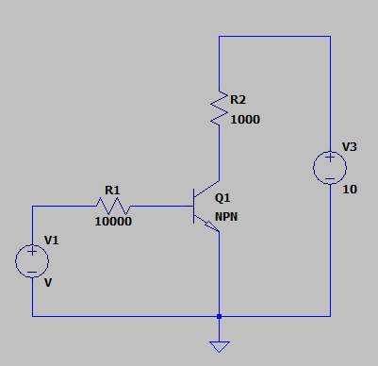

Figure 1: SPICE setup of the simulation
Answers:
            - When the input voltage V1 is 10V, the collector voltage is 36.48 mV.
            - When V1 is 0V, the collector voltage is 10V.
            - 1.032 V input voltage resulted in an output of 5.059V.
            - The following setup employs a sinusoidal input of 10mV peak at 50kHz.
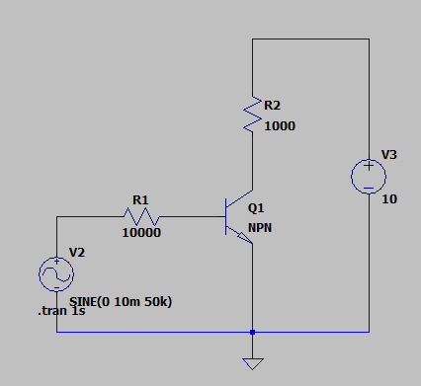

Figure 2: Sinusoidal input
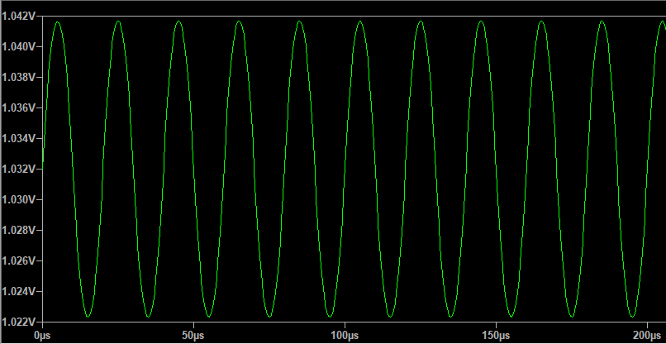

Figure 3: Sinusoidal input applied to the transistor

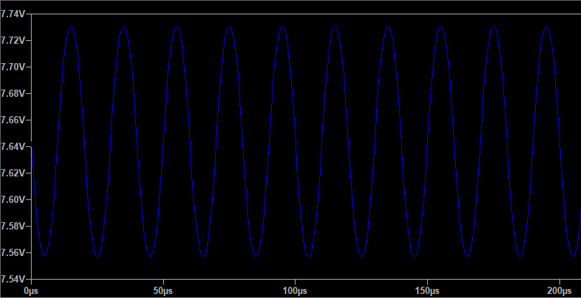

Figure 4: Resultant output signal

Discrete Amplification with Transistors
In this example, the setup is required to indicate whether the ambient temperature is above 60℃. The employed NTC thermistor is represented with R1, and its resistance at 60℃ is 2490 Ω. Therefore, R2 must be:
$$0.7V= 12V*\frac{R2}{R2+2490}$$
$$R2≅155Ω$$
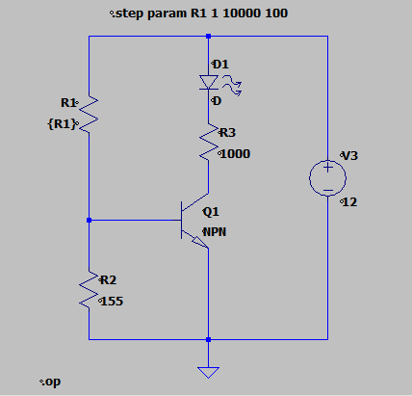

Figure 5: Simulation setup

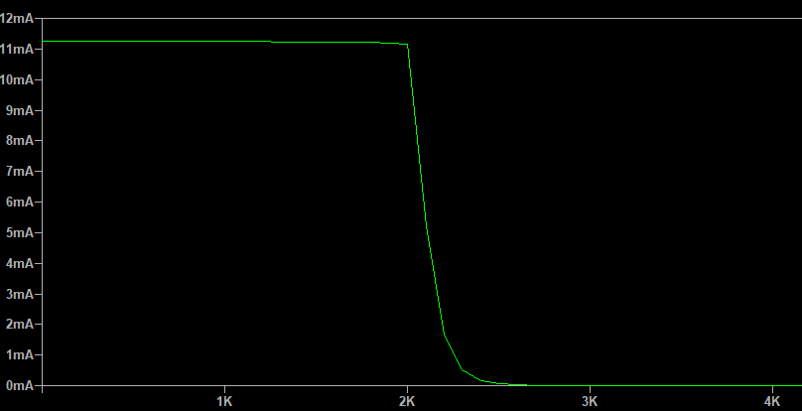

Figure 6: Output current on the LED

Mathematical Calculations for ADCs

            - Calculate the variance of a quantized signal:
$$σ^{2}=\int_{-\frac{q}{2}}^{\frac{q}{2}}{e^{2}P\left(e\right)de=\frac{q^{2}}{12}}$$
$$P\left(e\right)=\frac{1}{LSB}=\frac{1}{q}$$
$$=\int_{-\frac{q}{2}}^{\frac{q}{2}}{\frac{e^{2}}{q}de=\left.\frac{e^{3}}{3q}\right|{0.5q \atop -0.5q}=\frac{q^{2}}{12} }$$

            - Calculate the SNR:
$$SNR=10\log\left(6A^{2}q^{2}\right);q=\frac{2A}{2^{N}}$$
$$=10\log\left(\frac{24A^{4}}{2^{2N}}\right)$$
$$=10\left[log24+4logA-2Nlog2\right]$$
$$=13.8+40logA-6.02N$$
$$…$$
            - ENOB:
$$ENOB=\frac{SNDR-1.76}{6.02}$$
SNR was given as 47.5 dB. So,
$$\frac{47.5-1.76}{6.02}=7.6 bits$$
SNDR as given 55.879 dB. So,
$$\frac{55.879-1.76}{6.02}=9 bits$$

            - 4 harmonics are present along with the fundamental frequency. Harmonics may be caused by nonlinearities in ADC.
            - When a larger bin for FFT is utilized, the noise floor scoots downwards. In this example, 6 harmonics are present along with the fundamental frequency.

$$LSB=\frac{110}{21000}=5.23μV/step$$

7.
 | VAR1 | VAR2 | VAR3 | VAR4 | VAR5 | VAR6 | VAR7 | VAR8
STD | 1.0512 | 1.0785 | 1.0328 | 0.9813 | 1.0180 | 1.0449 | 0.9808 | 1.0177
SNR  (dB) | 99.2289 | 98.9220 | 99.3627 | 99.8782 | 99.5034 | 99.2208 | 99.8827 | 99.5166
ENOB  (bits) | 16.1908 | 16.1399 | 16.2131 | 16.2987 | 16.2364 | 16.1895 | 16.2995 | 16.2386

Methodology:
SNR = 10 * log(mean_value / standard_deviation)
ENOB = ( SNR – 1.76 ) / 6.02

